Project Proposal

**Project Description:**

The title of my term project is Notion: College Edition. It is inspired by the organizational app, Notion, but will be targeted towards college students, like the name implies. Instead of being as open and free as Notion, it will provide specific templates (weekly agenda, master class to-do list, etc.) that college students would find useful. The home screen is the dashboard and pages can be accessed/added from there; it will have an emphasis on aesthetics. The calendar page of my project recursively finds the best possible time for a user’s task based on their priority level of it and other present tasks.

**Competitive Analysis:**

Wonderland: While my project is similar to this one in that it has a to-do list and is used in daily life, mine will include more features and pages. Wonderland is based on a singular screen while Notion: College Edition will be able to go back and forth between pages and create multiple new ones, making it more customizable.

PyPlanner: This project also has a feature of adding tasks to a calendar, however, it allows the user to input everything manually. Notion: College Edition finds the best possible time for the task based on the user’s preferences and adds it for them.

**Structural Plan:**

There are multiple classes for each major feature of the project, like buttons, textEditor, page, assignment, addTask. These classes will all be imported into a main file to be run. To store existing pages and load them, objects will be converted into strings and stored in a separate .txt file. The user will be able to navigate back and forth to pages by clicking buttons.

**Algorithmic Plan:**

The most algorithmically complex part of my project is the recursive backtracking calendar algorithm. Users will rank the priority of their task and the calendar will utilize this algorithm to generate the “best” calendar possible. It examines the current tasks and times that the user is able to manually put in and then sorts the new tasks into the calendar in the best way.

**Timeline Plan:**

1. Button and basic text editor completed - TP 1 (November 18)
2. Basic dashboard - TP 1 (November 18)
3. Basic template pages graphics and options message - TP 1 (November 18)
4. Save and store pages - TP 2 (November 23)
5. Calendar recursive backtracking algorithm - TP 2 (November 23)
6. Navigation between pages - November 25
7. Additional features to increase convenience - TP 3 (December 1)

**Version Control Plan:**

I will backup and store my code by copy-pasting and saving it in Google Docs.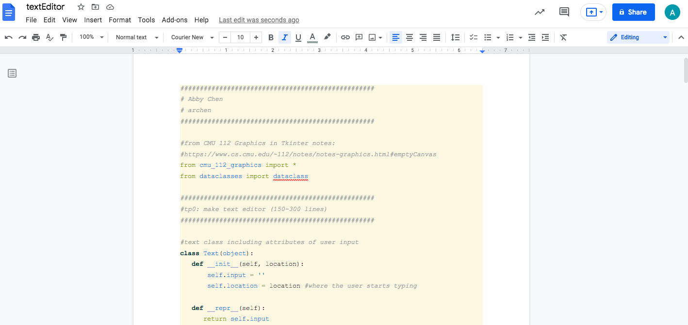

**Module List:**

I will not be using any modules before MVP.

**TP2 Update:**

There are no major updates.

**TP3 Update:**

The user is able to edit entries in the master to-do list. There are no other major changes.